City of Palatka
Pilot Study to Improve Water Quality
Public Notice and Frequently Asked Questions

The City of Palatka is beginning a 90 day pilot study at the water plant to improve water quality and reduce Disinfection By-Products in the drinking water. Working with the Florida Rural Water Association and Florida Department of Environmental Protection the City will be feeding small quantities of hydrogen peroxide (H₂O₂) and testing its effectiveness to oxidize (chemically reduce) color, odor, taste, iron, sulfide (H₂S), and natural occurring organics such as tannins as measured by total organic carbon. A secondary goal is to reduce the amount of chlorine needed in the water distribution system.

Hydrogen peroxide has been effectively and successful used by other cities and water utilities around Florida. Peroxide is a well-known oxidant more frequently used in wastewater treatment to control hydrogen sulfide (H₂S). H₂O₂ is one of the recognized alternative preoxidants recommended by EPA in water pre-treatment in lieu of chlorination for lowering disinfection by-product formation.

The pilot study will inject peroxide in the raw well water and used up (chemically reduced to oxygen and water) prior to chlorination. Hydrogen peroxide will not be present in the drinking water. Chlorine will continue to be fed at the point of entry.

Frequently Asked Questions

What is Hydrogen Peroxide?

Hydrogen Peroxide is chemically water with an additional oxygen molecule -- (H₂O₂). During the reaction the oxygen molecule is liberated and chemically oxidizes (reduces) impurities in the raw water, including iron, sulfur, organics, tannins, and total organic carbon, which contribute to color, odor, and taste. As a result, hydrogen peroxide is a candidate for pre-oxidation of disinfection by-product precursors. Peroxide is ranked second to chlorine for the oxidation of hydrogen sulfide and higher than potassium permanganate and ozone, see reference below.

Unlike chlorine, hydrogen peroxide produces no harmful or regulated chlorination byproducts. Additionally peroxide is a common household item, although the concentration we will be using is higher for water treatment.

What concentration of Hydrogen Peroxide be using?

Hydrogen Peroxide found in most pharmacies has a strength of 3% H₂O₂ which is equivalent to 30,000 parts per million (ppm). The City of Palatka will be injection 3.5 parts per million of H₂O₂ which is equivalent to 0.00035% - a very small concentration of hydrogen peroxide!

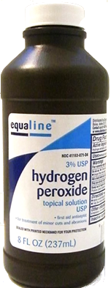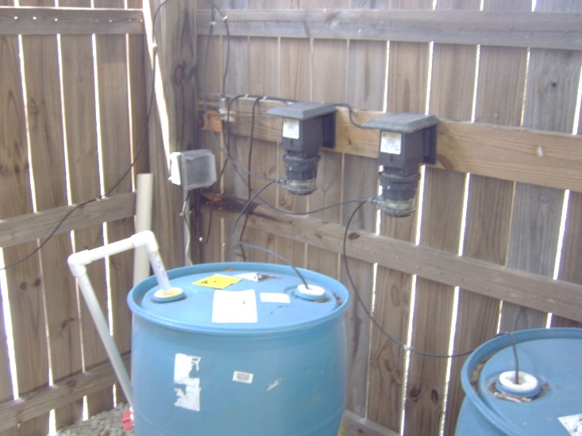
3% solution = 30,000 ppm
Injecting 0.00035% = 3.5 ppm

How was this concentration of Hydrogen Peroxide determined?

The City and Florida Rural Water Association conducted field tests at R. C. Willis Water Treatment Plant on the raw well water. Hydrogen sulfide odor was reduced quickly so the reaction with appears to be almost instantaneous. Other impurities (such as iron, manganese, organics, tannins, etc.) took five to twenty minutes to oxidize.

Why is the pilot study being conducted?

This treatment pilot study is designed to provide improved water quality to our customers and to continue to meet the stringent US Environmental Protection Agency and Florida Department of Environmental Protection regulations. The pilot study will determine if hydrogen peroxide is a realistic, effective, and economical solution for the City of Palatka.

Will there be any peroxide in the water I drink?

No. The City will monitor the feed and control the concentration such that there is no peroxide prior to chlorination.

Why can’t the City stop using chlorine altogether?

Florida Department of Environmental Protection regulations require the City to chlorinate at the plant and maintain a low level of chlorine in the water distribution system at all times. Chlorine protects public health from bacteria and other naturally occurring organisms that have been proven to cause illness.

Why can’t peroxide replace chlorine as a disinfectant?

Hydrogen Peroxide can kill some bacteria in the short-term but is not a long-term disinfection agent (does not maintain a residual in the water distribution system). Additionally the US Environmental Protection Agency and Florida Department of Environmental Protection regulations do not allow Hydrogen Peroxide to be used for public health in water distribution systems.

When will the pilot study be conducted?

The pilot study is planned for ______ through _________ – 90-days. This duration is based on recommendations from the Florida Rural Water Association and Florida Department of Environmental Protection regulations. If there are any changes in the duration of the pilot study, customers will be notified.

Who will be affected?

The pilot study will include all customers of the Palatka Water System.

Will customers notice any changes in the water during the pilot study?

Palatka customers may experience a difference in taste and/or smell in the water during this temporary change in treatment. Initially during the first two weeks of the pilot study, the changes will likely be less apparent but will later increase as the system adjusts to the change. These are normal occurrences and carry no negative health effects.

Can I drink the water during this pilot study?

The water will continue to meet Federal and State standards for safe drinking water during this pilot study; however, customers may notice an improvement in taste and/or smell. Each individual has his or her own sensitivity level to the taste and/or odor. Many may detect no change at all. The chlorine taste and smell may increase slightly during the first two weeks of the pilot study is normal and poses no health risk. Once the system meets equilibrium the City will attempt to lower chlorine levels.

Will the water be safe to use?

Yes, the water will be safe for people and animals to drink, for cooking and bathing, watering the garden, and for all other common uses including kidney dialysis processing, in the preparation of water for fish tanks and ponds, and for businesses requiring highly-processed water.

People and businesses that normally take special precautions to remove chlorine from tap water, such dialysis centers, medical facilities and aquatic pet owners, should continue to take the same precautions during the temporary switch.

Most customers will not need to take any precautions as the water remains safe to drink and is treated according to both state and federal standards.

If I have questions, who should I call for more information?

For more information, please call or email:

- Kayla Wylie, RC Willis Treatment Plant at (386) 530-1058 or kwylie@palatka-fl.gov

- Jonathan Griffith, Public Works Director at (386) 329-0103 ext. 325 or jcgriffith@palatka-fl.gov

EPA (1999), Alternative Disinfectants and Oxidants Guidance Manual, Doc No. 815-R-99-014]
ibid
Water Treatment: Principles and Design, Second Edition / MWH. (2005) revised by John Critienden, et al, pp. 512-513.

