Jud Neufeld |  | Jonathan C. Griffith
Chair |  | Interim City Manager
John P. Browning, Jr. | 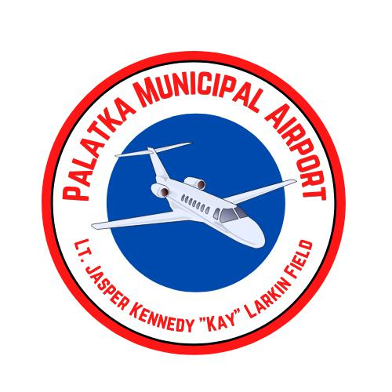 | Jane West, Esq.
Board Member |  | City Attorney
Wayne McClain |  | Yul McNair
Board Member | PALATKA | Airport Manager
Melissa C. Miller | MUNICIPAL
Melissa C. Miller | AIRPORT
Board Member | AIRPORT
Board Member | Lt. Jasper Kennedy "Kay" Larkin
Ken M. Johnson | Field (28J)
Board Member | Advisory Board Meeting
Dana Jones | Minutes
Board Member | January 3, 2024
Arthur Billingsley
Board Member

The minutes of the proceedings of the regular meeting of the Airport Advisory Board meeting held on January 3, 2024, at Palatka Municipal Airport, 4015 Reid St., Palatka, FL 32177. The meeting begins at 17 minutes 58 seconds on the YouTube recording: https://www.youtube.com/watch?v=4PeaQz-Ski4 In accord with the State of Florida’s retention schedule, this link will expire after two years.

- Welcome of Guests and Call to Order at 12:00 PM
- Swearing in Ceremony - Arthur Billingsley
The Clerk administered the Oath of Office to Arthur Billingsley. Mr. Billingsley introduced himself. He has been a pilot for 50 years +/-. He is an engineering consultant for the U.S. Defense Department and flies his airplane to Washington D.C. regularly.

- Roll Call
Jud Neufeld, Chair - Present
John Browning, Board Member - Present
Wayne McClain, Board Member - Present
Melissa Miller, Board Member - Present
Ken Johnson, Board Member - Not present
Dana Jones, Board Member - Present
Arthur Billingsley, Board Member - Present
Robbi Correa, Mayor, Commission liaison - Present
Also present: Jonathan Griffith, Interim City Manager; Marcia Carty, Finance Director; Jane West, City Attorney; Sunni Krantz, City Clerk; Yul McNair, Airport Manager; Sophia Smith, Airport Administrative Assistant; Jayde Baggs, Project Manager/Grants Administrator; Elizabeth van Rensburg; Matt Singletary, Passero & Associates; Richard Nelson; Rick Cunningham

- Approval of Minutes of November 1, 2023 Meeting
Motion to approve by Ms. Jones. Second by Mr. Browning. Motion passed unanimously.

- Chairman's Comments
Chair Neufeld expressed appreciation for everyone’s service and support of the airport.

- Public Comments
The floor was opened to public comment. Hearing none, the floor was closed to public comment.

- Regular/Public Business
- RECOMMENDATION - Change date of Airport Advisory Board Meeting
Mr. McNair expressed Staff feels it would be better to push the meeting to later in the month. This would enable Airport Staff and the Finance Department to prepare the financial reports for the prior month. Ms. Jones recommended the 4th Wednesday of the month. The consensus of the board agreed. February 27th will be the next meeting date.

- Airport Update
- Proposals for airport leases appraisals.
Mr. Griffith advised the City has obtained two proposals for appraisal services. His recommendation is to proceed with the appraisal services of Cooksey and Associates (the low bidder). A benefit of the appraisal will be able to back up our ground leases. Mr. Griffith advised there is another area to include in the scope of work. The item will be taken to the Commission. Mr. McClain noted when this comes back it will bring revenue to the Airport.

- Airport land release/acquisition.
Mr. Griffith updated the board, the City Commission approved a land swap between the City and Mr. Jeff Nations. The area the City will be conveying to Mr. Nations from the Airport has been released by the Federal Aviation Administration. Within the property being conveyed to Mr. Nations, is the old, abandoned runway outside of the fence. The City will retain a 60 ft strip of his property (to be a platted right of way). The Utility Fund must buy a portion of land from the Airport Enterprise Fund for it to be a Public Works site. The results of the land swap will be that the airport ends up with money in the bank and additional acreage. Mr. Griffith clarified this is not a through-the-fence transaction, where Mr. Nations could land and go into his property. This will be a light industrial development outside the (airport) fence. Mr. Griffith advised the due diligence period will end on January 11.

- Financial Report November 2023
Ms. Carty presented the airport financials ending Nov. 2022 (see handout). The Finance Department is transferring pro-rata from the General Fund to the Airport Enterprise Fund through the year what has been budgeted to transfer. In the past it was transferred in one lump. Mr. Griffith advised the pro-rata transfer will continue until we get further along in the year.

- Business Report
Mr. McNair presented a business report. He expressed AVGas fuel sales have been impacted by the Airport’s fuel tanks being offline. The AVgas services are limited. We have 2 12,000 tanks (one for AVgas and one for Jet A) AVgas was primarily self-serviced. We used the storage tank for Jet A for storage for a 3,000-gallon truck. We were able to use a truck for AVgas to minimize the impact on our customers.

Mr. McNair expressed hangar rate adjustment began on November 1.

Discussion commenced regarding maintenance of the hangars. Mr. McClain asked for the balance in the maintenance fund. He expressed concern on the maintenance of the front entrance. Chair Neufeld expressed concern of the maintenance (painting the white trim and scraping) of some of the older hangars. Mr. Browning suggested the maintenance begin with the front gates and move back. Mr. Browning pointed out there is $30,000 for hangar maintenance that has not been spent from this budget.

Mr. McNair spoke on upcoming projects. We will have a formal program handling the airport wildlife.

- Closing Comments
Nothing further.
Motion to adjourn at 1:00 PM by Mr. McClain.

