ELIZABETH VAN RENSBURG  CHAIR  ALLEN SHEFFIELD  VICE CHAIR  LARRY F. BEATON  BOARD MEMBER  CHRISTOPHER HOLLISTER  BOARD MEMBER  BREANNA PIERCE  BOARD MEMBER  PATTI VOGT  BOARD MEMBER  TIMOTHY JEFFERSON  BOARD MEMBER  MARY JANE ROSA  ALTERNATE BOARD MEMBER | 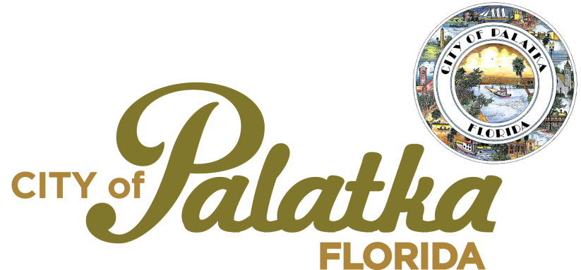  HISTORIC PRESERVATION BOARD  Regular meeting 1st Thursday of each month at 4:00 p.m. | TROY BELL, ICMA-CM  MS-FINANCE  CITY MANAGER  LORENZO AGHEMO, ARP  PLANNING DIRECTOR  JANE WEST, ESQ.  CITY ATTORNEY

AGENDA
March 7, 2024
at 4:00 PM
1. CALL TO ORDER
a. Invocation
b. Pledge of Allegiance
c. Roll Call
d. Appeal Procedures & Ex Parte Communication
2. APPROVAL OF MINUTES
a. February 1, 2024
3. PUBLIC COMMENTS (Speakers limited to three minutes - no action taken on items)
4. REGULAR BUSINESS
* a. HPB Case 23-36: Certificate of Appropriateness for front and rear porch improvements at 313 Dodge Street. Owner: Charleen Hosein House Address: 313 Dodge Street, Palatka, FL 32177 PIN: 42-10-27-6850-0420-0072
* b. This is an application for a Certificate of Appropriateness for a series of exterior improvements at the former office of ‘Patricia Banks Accounting’ at 519 Crill Ave., parcel number 42-10-27-6850-0410-0031. The parcel is within a Residential, Single-Family (R-1) zoning district, and within the South Historic District. The applicant has converted this structure to a residential land use.
* c. This is an application for a Certificate of Appropriateness for the installation of a sun shade canopy over parts of the outdoor recreational area. Owner: First Baptist Church of Palatka, Inc.
Address: 501 Oak Street PIN: 42-10-27-6850-0270-0010

5. STAFF AND BOARD MEMBER COMMENTS
NAPC webinars

6. EMERGENCY ITEM
HPB 24-08: City of Palatka Request for a Certificate of Appropriateness for demolition of 512 Emmett Street.

7. ADJOURN

NOTICES: ANY PERSON AGGRIEVED BY A DECISION OF THE BOARD MAY, WITHIN 15 DAYS THEREAFTER, APPLY TO THE CITY COMMISSION FOR A REVIEW OF THE BOARD'S DECISION. SUCH APPLICATION MUST BE FILED WITH THE CITY MANAGER IN WRITING. OBJECTIONS BY PROPERTY OWNERS TO NATIONAL REGISTER NOMINATION(S) MUST BE NOTARIZED TO BE INCLUDED IN THE RECORD. SECTION 54-4-74, PALATKA MUNICIPAL CODE

ANY PERSON WISHING TO APPEAL ANY DECISION MADE BY THE HISTORIC PRESERVATION BOARD WITH RESPECT TO ANY MATTER CONSIDERED AT SUCH MEETING WILL NEED A RECORD OF THE PROCEEDINGS, AND FOR SUCH PURPOSE MAY NEED TO ENSURE THAT A VERBATIM RECORD OF THE PROCEEDINGS IS MADE, AT THE APPLICANT'S EXPENSE, WHICH RECORD INCLUDES THE TESTIMONY AND EVIDENCE UPON WHICH THE APPEAL IS TO BE BASED. FS 286.0105

PERSONS WITH DISABILITIES REQUIRING ACCOMMODATIONS IN ORDER TO PARTICIPATE IN THIS MEETING SHOULD CONTACT THE CITY CLERK'S OFFICE AT 386-329-0100 AT LEAST 24 HOURS IN ADVANCE TO REQUEST ACCOMMODATIONS.

