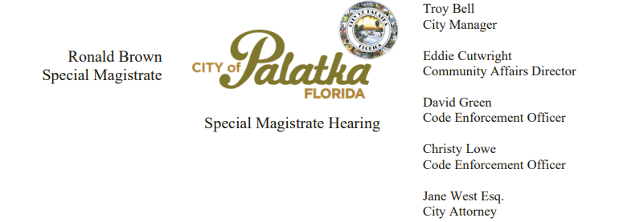
CODE ENFORCEMENT HEARING WITH SPECIAL MAGISTRATE
FEBUARY 20, 2024
1:30 P.M.

- Call to Order
- Briefing by Special Magistrate
- Swearing in of Code Enforcement Officers
  - Eddie Cutwright
  - David Green
  - Christy Lowe

NEW CASES

- Case # 2023-191 /Officer David Green 600 Emmett Street Palatka, Florida 32177

Section 30-169 Building fronts and sides abutting streets or public areas.
Description: Mold and Mildew

Section 30-169 Building fronts and sides abutting streets or public areas.
Description: Rotten and Weakened Wood

- Case # 2023-190/Officer David Green 418 River Street Palatka, Florida 32177

Section 30-169 Building fronts and sides abutting streets or public areas.
Description: Deteriorating Paint

CASES FOR 2nd REVIEW

- Case # 2023-061 / Officer Christy Lowe 512 Emmett Street Palatka, Florida 32177

First Hearing: May 16, 2023 @ 1:30 p.m.
Compliance Date: August 15, 2023

Section 30-32(a) Prohibited Conditions and Public Nuisances
Description: Building Deteriorating

Section 30-32(a) Prohibited Conditions and Public Nuisances
Description: Roofing in Disrepair

Section 30-32(a) Prohibited Conditions and Public Nuisances
Description: Windows Broken or Missing

Section 30-32(a) Prohibited Conditions and Public Nuisances
Description: Trash and Debris

Section 30-32(a) Prohibited Conditions and Public Nuisances
Description: Overgrown grass, tree limbs, broken tree limbs on property

